
Tribhuvan University
Faculty of Humanities and Social Sciences
WEB-BASED JOB SEARCH SYSTEM
PROJECT PROPOSAL
Submitted to
Department of Computer Application
Nepathya College
Tilottama-5, Manigram, Rupandehi
In partial fulfillment of the requirement for the Bachelors in Computer Application
Submitted By
Basanta Parajuli
(6)

Contents
1. Introduction 2
2. Problem Statement 2
3. Objectives 3
4. Scope and Limitation 3
5. Literature Review 3
5.1 Overview of Job Search Platforms 3
5.2 Key Technologies 4
5.3 Challenges in Existing Systems 4
5.4 Research Gaps 4
5.5 Conclusion 4
6. Methodology 4
6.1 Requirement Identification 5
6.2 Feasibility Study 6
6.3 High-Level Design of System 6
6.3.2 Methodology / Working Mechanism 7
6.3.3 Use Case diagram 8
7. Gantt Chart 9
8. Expected Outcome 9
9. References 10

Table of Figures
Figure 1: Waterfall Methodology 5
Figure 2: System flowchart 7
Figure 3: Use Case Diagram 8
Figure 4: Gantt chart 9

- Introduction
The Job Search System is designed to bridge the gap between job seekers and employers by offering a streamlined platform that simplifies the job search and recruitment process. In today’s fast-paced digital world, finding the right job or the perfect candidate can be overwhelming. Traditional job search platforms often inundate users with a vast array of options, making it difficult to identify opportunities that align with their skills or to filter through unqualified candidates effectively. Our system seeks to address these challenges by providing a more focused and user-friendly experience.
This platform is tailored to meet the needs of both job seekers and employers. Job seekers can easily search for relevant opportunities using advanced filters, apply directly through the platform, and manage their applications in one place. On the other side, employers can quickly post job openings, review applications, and communicate with potential candidates through a dedicated dashboard. By focusing on simplicity, efficiency, and security, the Job Search System aims to enhance the overall job search experience for all users.
Our system leverages modern web technologies such as Java Spring Boot for the backend, PostgreSQL for data storage, and a responsive frontend built with HTML, CSS, and JavaScript. The Job Search System is poised to make job hunting easier and more efficient, benefiting both job seekers and employers alike.
- Problem Statement
- Fragmented Interfaces: Existing job platforms have disjointed interfaces, making the job search and application process cumbersome and time-consuming.
- Inefficient Recruitment Process: The lack of a unified platform leads to inefficiencies in job searching, application submission, and job posting.
- Inadequate Security: Current systems often lack robust security measures, leaving user data vulnerable to breaches and privacy concerns.
- Poor Communication: The absence of real-time communication and tracking tools results in delays and missed opportunities in the recruitment process.

      - Objectives
- To create a unified platform that integrates job searching, application submission, and job posting into a single, cohesive interface.
- To enhance user experience by designing an intuitive, user-friendly interface that simplifies the job search and application process for both job seekers and employers.
- To ensure security by implementing robust authentication and session management protocols to protect user data and maintain privacy.
- To facilitate efficient communication by enabling real-time tracking of job applications and fostering streamlined communication between job seekers and employers.
- Scope and Limitation

Scope
- Simple user registration for job seekers and employers.
- Basic login/logout functionality, initially focusing on job seekers.
- Job search by title and location.
- Employers can post jobs with basic details.
- Basic dashboard for employers to manage posted jobs.
- Job seekers can view a list of jobs they've applied for.
- Responsive design for desktops and mobile devices.
- Basic security features like password encryption and authentication.

Limitations
- No advanced features like role-based access or third-party integrations.
- Minimal analytics or reporting features.
- No AI or machine learning capabilities.

- Literature Review

5.1 Overview of Job Search Platforms
Early job portals like Monster.com provided basic job listings, while modern platforms like LinkedIn and Indeed offer more advanced features, such as job recommendations and integration with social media.

5.2 Key Technologies
- Spring Boot is popular for building backend systems due to its simplicity.
- Thymeleaf is used for creating dynamic web pages.
- MySQL and PostgreSQL are common databases for storing user and job data.

5.3 Challenges in Existing Systems
- User Experience: Many platforms struggle with making their interfaces user-friendly.
- Security: Protecting user data is a major concern for all job platforms.

5.4 Research Gaps
- Personalization: There is still a need for better job matching.
- Accessibility: Many platforms need to improve how they serve users with disabilities.

5.5 Conclusion
Understanding these aspects helps in designing a job search system that is simple, secure, and user-friendly.

- Methodology
The project will use the waterfall methodology, where each phase is completed in a specific order. It starts with planning and defining the project's goals, followed by gathering and documenting all requirements. The system design is then created, leading to the development of the backend and frontend components. Once these parts are developed, they are integrated and thoroughly tested. After testing, the system is deployed to the production environment. Finally, a review is conducted, and the project is launched. This method ensures a clear, step-by-step approach to completing the project.
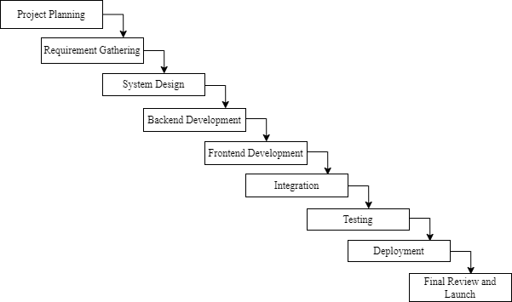

Figure 1: Waterfall Methodology

Requirement Identification

6.1.1 Study of Existing System
A detailed analysis of existing job search platforms, such as Indeed, LinkedIn, and Glassdoor, will be conducted to identify their strengths and weaknesses. This study will focus on features like user interface, search functionality, application tracking, and communication tools. The insights gained from this analysis will guide the development of the Job Search System, ensuring that it addresses the gaps in existing solutions.

6.1.1 Requirement Collection
Requirements will be gathered through surveys, interviews, and focus groups involving potential users, including job seekers and employers. The collected requirements will include both functional and non-functional aspects, such as user interface preferences, security expectations, and performance standards. This information will form the basis for the design and development phases of the project.

6.2 Feasibility Study

6.2.1 Technical Feasibility
The system will be developed using Java Spring Boot for the backend, ensuring scalability and robustness. The frontend will be built using HTML, CSS, and JavaScript, providing a responsive and interactive user experience. The feasibility study will confirm that the chosen technology stack is suitable for the project and that the necessary technical skills and resources are available.

6.2.2 Operational Feasibility
The Job Search System will be designed to fit within the existing resources and workflows available. The development will be carried out independently, utilizing current hardware and software tools without the need for additional personnel or advanced technologies. To ensure the system meets the operational needs of its intended users, user acceptance testing (UAT) will be conducted to evaluate its user-friendliness and efficiency. The system will be scalable within the limits of the project scope, accommodating the needs of job seekers and employers as the user base grows.

6.2.3 Economic Feasibility
This project will be developed with minimal financial outlay, limited to essential costs such as electrical and internet bills. The system will be built using existing resources, ensuring that no significant expenses are incurred. A cost-benefit analysis will focus on the practical aspects of developing a functional system that meets the project requirements without additional investments. The emphasis will be on leveraging available tools and technologies to create a reliable and efficient job search platform.

6.3 High-Level Design of System

6.3.1 System Flow Chart
A system flow chart will be created to visually represent the major processes within the Job Search System, such as user registration, job searching and job posting management. This chart will illustrate how data flows through the system and how different components interact.
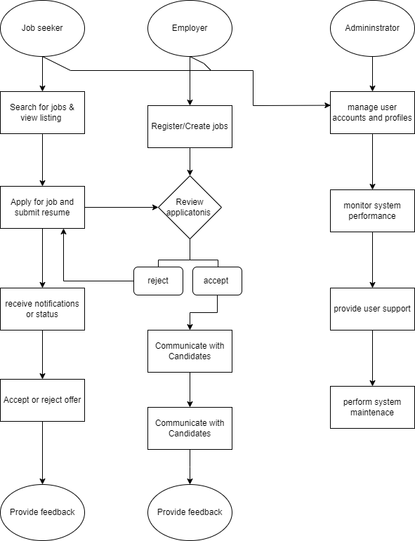

Figure 2: System flowchart

6.3.2 Methodology / Working Mechanism
  - User Registration & Login: Secure registration and login processes for job seekers and employers.
  - Job Posting & Searching: Employers post jobs, and job seekers search using various filters.
  - Application Process: Job seekers submit applications; the system tracks and updates their status.

6.3.3 Use Case diagram
The diagram effectively captures the key functionalities of the job search system, showing the different actions available to job seeker, employer and admin.
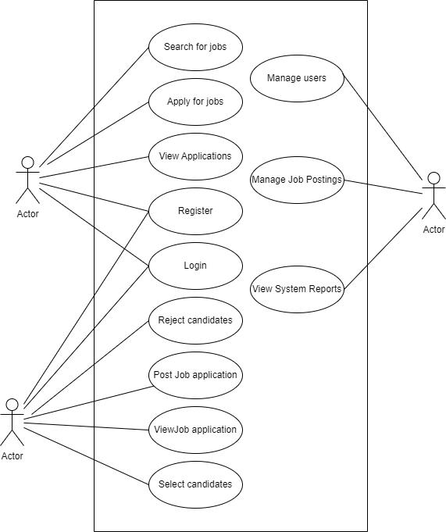

Figure 3: Use Case Diagram

- Gantt Chart
A Gantt chart will be provided to outline the project timeline, including key phases such as:
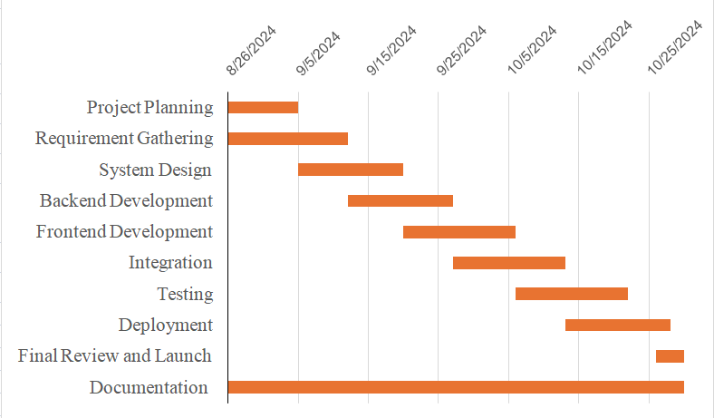

Figure 4: Gantt chart
Each phase will have specific start and end dates, along with dependencies to ensure that the project stays on schedule.
- Expected Outcome
The expected outcome of the project is a fully functional Job Search System that effectively serves both job seekers and employers. The system aims to streamline the job search and application process, making it easier and more efficient for users to find and apply for jobs. It should also enhance user satisfaction by providing a user-friendly interface, reliable performance, and essential features like job search, application submission, and job posting. Additionally, the system will be designed with scalability and security in mind, allowing for future growth and ensuring the protection of user data.
- References
  - Spring Boot Documentation. "Official Documentation," 2024. [Online]. Available: https://docs.spring.io/spring-boot/docs/current/reference/htmlsingle/. [Accessed: Aug. 20, 2024].
  - Java Tutorials. "Official Java Tutorials," 2024. [Online]. Available: https://docs.oracle.com/javase/tutorial/. [Accessed: Aug. 20, 2024].
  - PostgreSQL Documentation. "PostgreSQL Official Documentation," 2024. [Online]. Available: https://www.postgresql.org/docs/. [Accessed: Aug. 20, 2024].
  - Stack Overflow. "Developer Forum," 2024. [Online]. Available: https://stackoverflow.com/. [Accessed: Aug. 20, 2024].
  - Job Portal. "Butwal Rojgar," 2024. [Online]. Available: https://job.butwalmun.gov.np/. [Accessed: Aug. 20, 2024].

